Homework 5 STAT:3210 Experimental Design and Analysis

Yubing Li 00808366

**1. Problem 4.23:**

**(a)** The **Latin Square design** was used in this experiment. The response variable is the **assembly time** for a color TV component (Time).

The treatment factor is **assembly method** (Method). The number of the levels is **4**. (A, B, C, D)

The blocking factors are **order** (Order) and **operator** (Operator). The number of the levels for both blocking factors are **4**. (1, 2, 3, 4)

The total sample size is **16**.

**(b)** Model: $y_{ijk}=μ+α_{i}+τ_{j}+β_{k}+ϵ_{ijk}$, i,j,k = 1,2,3,4

The model assumptions are: the errors are **independent, homogeneous variance and normal**; the **additivity assumption** is valid for fixed effects.

**(c) ANOVA F test:**

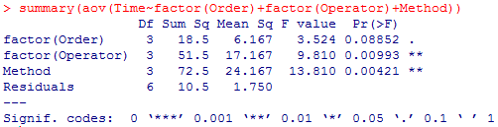 $H_{o}: τ_{1}=τ_{2}=τ_{3}=τ_{4}=0 vs H_{a}: τ_{j}≠0$ for at least one j

Since the **p-value = 0.00421** is less than 0.05, we **reject** **the null hypothesis** and conclude at least one of the assembly method has **significant effect** on the assembly time, after taking into account Order, Operator effects.

**(d) Incorrect ANOVA analyses:**

$H_{o}: τ_{1}=τ_{2}=τ_{3}=τ_{4}=0 vs H_{a}: τ_{j}≠0$ for at least one j

1) Ignore row blocking - Order:(R output on the next page)

The  **with**

2) Ignore column blocking - Operator:(R output on the next page)

The  **with**

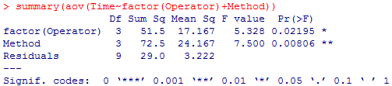

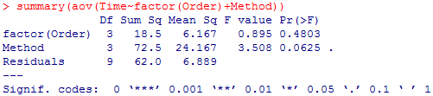

3) Ignore both blocking factors:

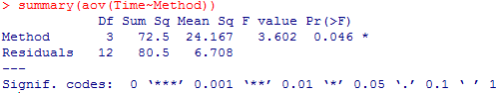The ${SS}_{E}=80.5$ **with ${df}_{E}=12$**

For the correct ANOVA test, we get ${SS}_{E}=10.5$ with ${df}_{E}=6$, which are relatively smaller. The incorrect analyses will return **larger error sum of square with a larger degree of freedom** for the error term.



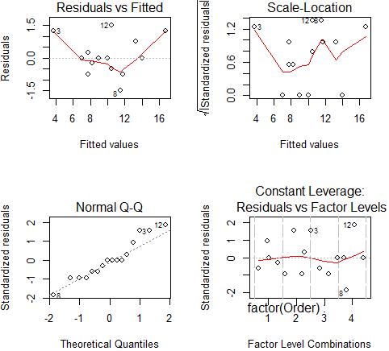**(e) Assumption:**

Normality:

Since the residuals are close to the diagonal reference line in the normal Q-Q plot, the **normal assumption is not violated**.

Constant Variance:

In the residual vs. fitted value plot, there’s no obvious violation against homogeneous variance. Therefore, the **constant variance assumption is not violated**.

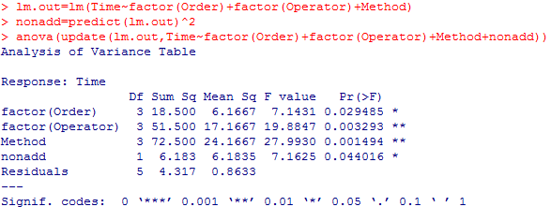Non-additivity test: H0: the model is additive vs. Ha: the model is nonadditive

Since the p-value is smaller than but very close to α level = 0.05, we say the nonadditive term is marginal significant but not highly significant. Therefore, we have **a little bit concern about the** **additivity assumption violation** but it’s not a big issue.

**(f) LSD: $H_{0}: μ_{i}=μ_{i'}$**  vs. $H_{A}: μ_{i}≠μ_{i'}$

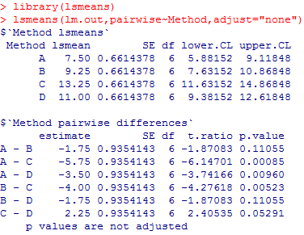By hand: By R:



We compare the estimate difference to the **LSD = 2.288876.**

Since the absolute value of differences for pairs **A-C, A-D, B-C** are larger than the LSD, we concludethese pairs have **significantly different means** for different methods. (We get the same results using R because the p-value for pairs A-C, A-D, B-C are smaller than 0.05, we reject the null hypothesis.)

However, the absolute value of differences for pairs **A-B, B-D, C-D** are smaller than the LSD, these pairs **are not significantly different** in means for different methods.

The test is controlled with **comparison-wise error of α = 0.05** for each pair.

**(g) HSD: $H_{0}: μ_{i}=μ_{i'}$**  vs. $H_{A}: μ_{i}≠μ_{i'}$ for all pairs (i, i’)

We compare the estimate difference to the **HSD = 3.238134.**

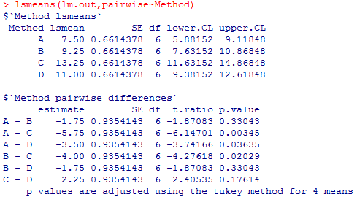By hand: By R:

Since the absolute value of differences for pairs **A-C, A-D, B-C** are larger than the HSD, we concludethese pairs have **significantly different means** for different methods. (We get the same results using R because the p-value for pairs A-C, A-D, B-C are smaller than 0.05, we reject the null hypothesis.)

However, the absolute value of differences for pairs **A-B, B-D, C-D** are smaller than the HSD, these pairs **are not significantly different** in means for different methods.

The test is controlled with **experiment-wise error of exactly α = 0.05** for all 6 pairs.

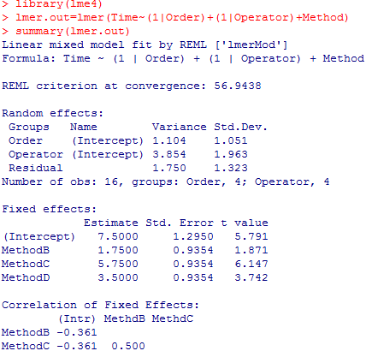**(h) Random factors:**

1) Estimation:

$${{\hat{σ}}_{Order}}^{2}$$

$\frac{{MS}_{Order}-{MS}_{E}}{p}=\frac{6.167-1.750}{4}=$**1.10425**

$${{\hat{σ}}_{Operator}}^{2}$$

$\frac{{MS}_{Operator}-{MS}_{E}}{p}=\frac{17.167-1.750}{4}=$**3.85425**

2) ${{\hat{σ}}_{Order}}^{2}=$ 1.104 and ${{\hat{σ}}_{Operator}}^{2}=$ 3.854, the results are the **same**.

3) LSD: (R output on the next page)

$H_{0}: μ_{i}=μ_{i'}$ vs. $H_{A}: μ_{i}≠μ_{i'}$

Since the p-value for pairs **A-C, A-D, B-C** are smaller than 0.05, we reject the null hypothesis and conclude these pairs havesignificantly different means for different methods.

And pairs **A-B, B-D, C-D** are not significantly different in means for different methods.

Yes, the conclusions **coincide with** the previous LSD test in (f) for all population.

No, the SE of individual means (1.2950 vs. 0.6614) **don’t coincide with** the perivous test**.**

4) HSD:

vs. for all pairs (i, i’)

Since the p-value for pairs **A-C, A-D, B-C** are smaller than 0.05, we reject the null hypothesis and conclude these pairs havesignificantly different means for different methods.

And pairs **A-B, B-D, C-D** are not significantly different in means for different methods.

Yes, the conclusions **coincide with** the previous HSD test in (g).

No, the SE of individual means (1.2950 vs. 0.6614) **don’t coincide with** the perivous test**.**

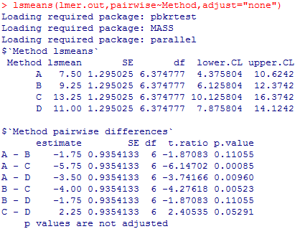LSD:

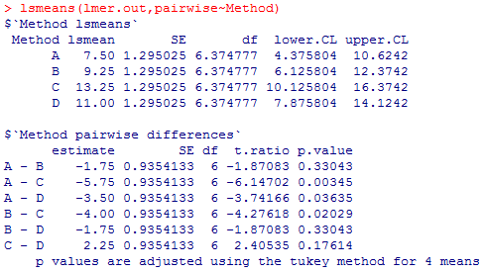HSD:

**(i) Unbalanced:**

$H_{o}: τ_{1}=τ_{2}=τ_{3}=τ_{4}=0 vs H_{a}: τ_{j}≠0$ for at least one j

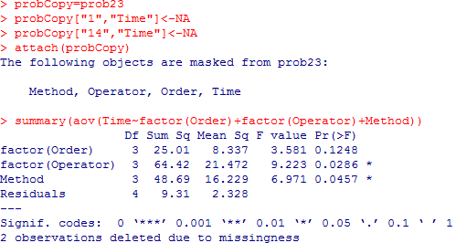

Since the **p-value = 0.0457** is less than 0.05, we **reject** **the null hypothesis** and conclude at least one of the assembly method has **significant effect** on the assembly time. (However, the p-value is relatively larger than the original test and the dfe is smaller than the one for original test (4<6). )

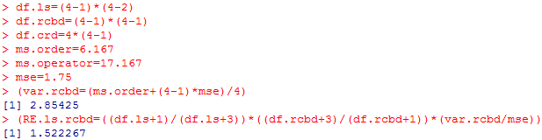**(о)** 1) LS vs. RCBD w/o Order:

The relative efficiency is **1.522267**. Approximately 1.522267 times as many replicates of each treatment would be needed with a RCBD with only Operator as blocks to obtain the same sensitivity by LS. Therefore, the blocking by Orders did better than w/o blocking Orders.

2) LS vs. RCBD w/o Operator:

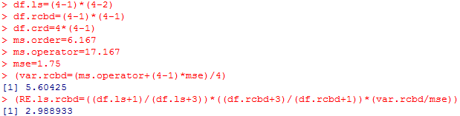

The relative efficiency is **2.988933**. Approximately 2.988933 times as many replicates of each treatment would be needed with a RCBD with only Order as blocks to obtain the same sensitivity by LS. Therefore, the blocking by Operators did better than w/o blocking Operators.

3) LS vs. CRD:

The relative efficiency is **2.931692**. Approximately 2.931692 times as many replicates of each treatment would be needed with a CRD without any blocks to obtain the same sensitivity by LS. Therefore, the blocking by Orders & Operators did better than w/o blocking Orders & Operators.

**2. Problem 4.36:**

**(a)** The **Graeco-Latin Square Design** was used in this experiment. The response variable is the **assembly time** for a color TV component (Time).

The treatment factor is **assembly method** (Method). The number of the levels is **4**. (A, B, C, D)

The blocking factors are **order** (1, 2, 3, 4), **operator** (1, 2, 3, 4), **workplaces** (α, β, δ, γ). The number of the levels for all blocking factors are **4**. The total sample size is **16**.

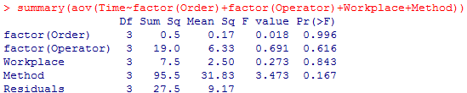**(b) ANOVA F test:**

$H_{o}: τ_{1}=τ_{2}=τ_{3}=τ_{4}=0 vs H_{a}: τ_{j}≠0$ for at least one j

Since the Method’s **p-value = 0.167** is larger than 0.05, we **cannot reject** **the null hypothesis** and conclude the assembly method **doesn’t have** **significant effect** on the assembly time, after taking into account Order, Operator and Workplace effects.

**(c)**

For 3-way ANOVA (LS): ${df}_{E}=6$, p-value = **0.00421**

For 4-way ANOVA (GLS): ${df}_{E}=3$, p-value = **0.167**

The dfe in 4-way ANOVA test is smaller than the p-value in 3-way ANOVA test (3<6).

The p-value in 4-way ANOVA test is much larger than the p-value in 3-way ANOVA test. (0.167 > 0.00421)

Since more degree of freedom got lost in the 4-way ANOVA test, **the F test is less sensitive**, w/ larger p-value.

**3. Problem 4.22:**

**(a)** The **Latin Square Design** was used in this experiment. The response variable is the **reaction time** (Time)of a chemical process.

The treatment factor is **catalyst** (Catalyst). The number of the levels is **5**. (A, B, C, D, E)

The blocking factors are **Batch** (1, 2, 3, 4, 5) and **Day** (1, 2, 3, 4, 5). The number of the levels for both blocking factors are **5**. The total sample size is **25**.

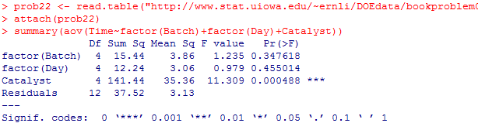**(b) ANOVA F test:**

$H_{o}: τ_{1}=τ_{2}=τ_{3}=τ_{4}=τ_{5}=0 vs H_{a}: τ_{j}≠0$ for at least one j

Since the **p-value = 0.000488** is less than 0.05, we **reject** **the null hypothesis** and conclude at least one of the catalysts has **significant effect** on the reaction time, after taking into account Batch and Day effects.

**(c) Relative Efficiency:**

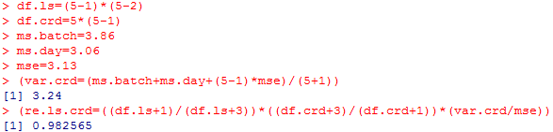

The relative efficiency of Latin Squares vs. CRD is 0.98257. It means that approximately 0.98257 times as many replicates of each treatment (Catalyst) would be needed with a CRD (without any blocks) to obtain the same sensitivity as obtained by the LS. In other words, **the blocking is not very efficient**.